82

Tutoring Log
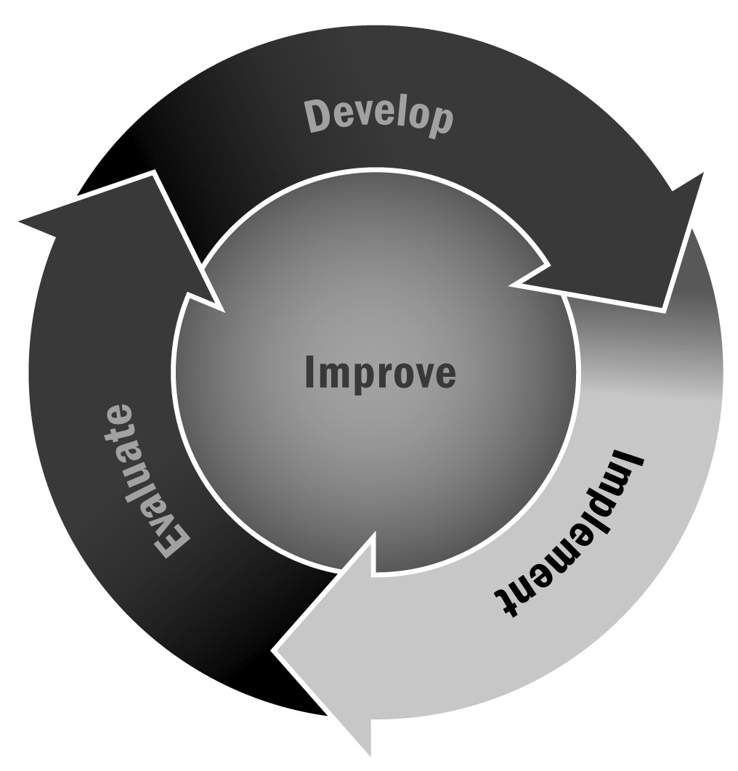
In Chapter 4, you learned about tutoring activities in afterschool and expanded learning programs. Documenting the sessions that a tutor completes with youth is an important component of information sharing for school day teachers and program staff members who also work with youth.
Directions: The form on the following page can be used by the afterschool and expanded learning tutor to record information about his or her work with an individual youth over time. During each tutoring session, record what the young person studies and accomplishes. In the “Notes” column, include areas in which the young person needs work, successes experienced, or any other pertinent information. In the last column, ask youth (grades 3–12) to write down an accomplishment or a question or concern. For K–3 youth, ask them for their ideas and write them in the column for them.
This log can be used throughout a semester or program session to capture progress and to serve as a record of what a young person is studying. It should be shared with classroom teachers periodically. Classroom teachers can complete the bottom section with questions, notes, and additional areas in which the young person should concentrate.

Tutoring Log
Youth Name: |  | Tutor Name:

Date | Subjects/Topics Studied | Work Accomplished | Notes | Youth Comments
Teacher Notes
Date |  | Questions/Areas for Additional Focus

